LSST Camera Hexapod hardware re-verification

(after Actuator Refurbishing)

**Prepared:** R.Tighe and M.Rivera, Aug-Oct 2021

**Revised:** J.Sebag, D.Neill, C.Claver, H.Drass.

**1. Introduction**

The required specifications to be met in the verification tests reported here, are those defined in the Hexapod and Rotator Specification Document, D. Neill, J. Sebag, W. Gressler, LTS-206, 2014.

The manufacturer (MOOG, CSA Engineering) developed an acceptance testing procedure and final report, based on the requirements in LTS-206. These documents are the LSST Hexapods and Rotator Acceptance Test Procedure, TP-7403-100, 9/25/17, and the LSST Hexapods and Rotator Acceptance Test Report, TR-7403-100, 4/27/18, respectively.

After refurbishing all of the seven actuators of the camera hexapod (six struts plus one spare), re-verification testing was done in the 3rd floor of the LSST building at the summit of the Vera Rubin Observatory. Most of the MOOG report hardware tests were re-done and are reported here in a different order. The order corresponds to how critical a specification is to Image Quality, Telescope and Instrument Operation, Engineering and general good-to-have considerations, as extracted from the Scientific, Optical, Operational and other requirements stated in the LTS-206 document.

In short, the testing of specifications reported here, starts with the tighter specs and ends with the looser specs.

To skip reading all the report, Table 14 in Section 4 below, summarizes the re-verification results.

**2. Measurement set-up and Tools**

Figures 1 and 2 show the measuring instruments and measurements setup.

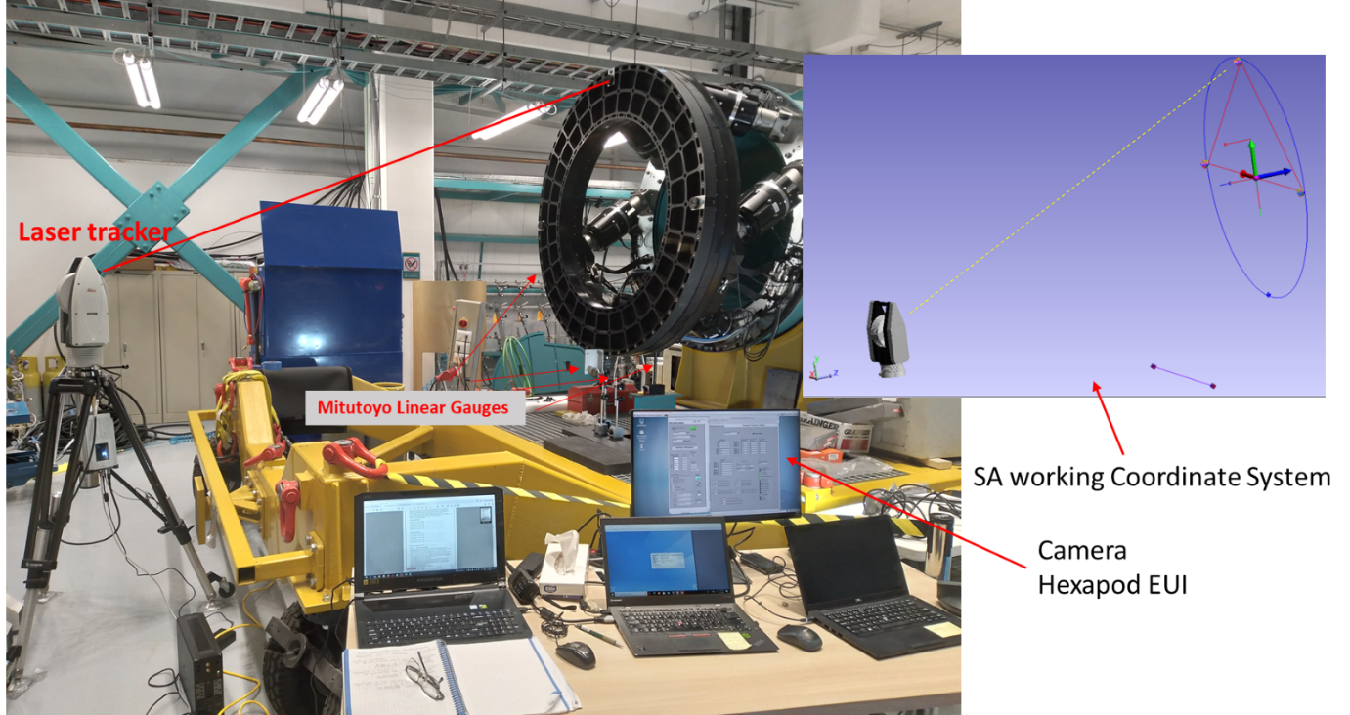

**Fig 1.** Laser Tracker, Linear Gauges and control setup are shown here.

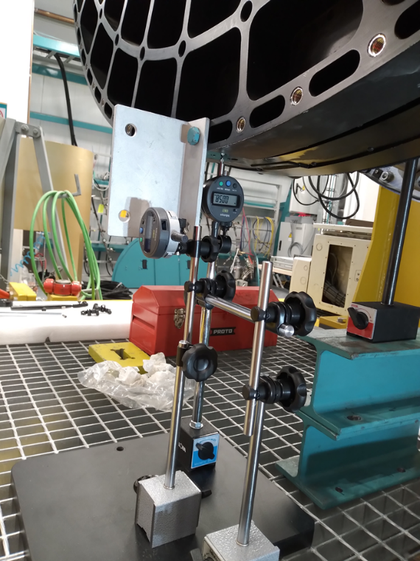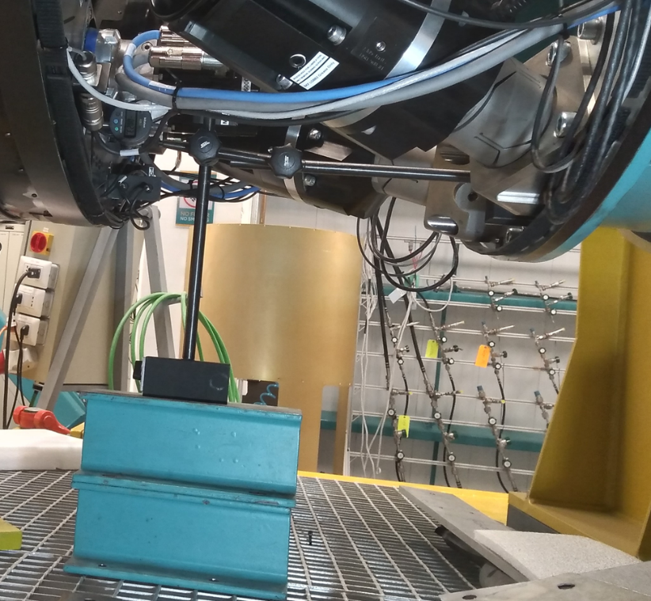

(b)

(a)

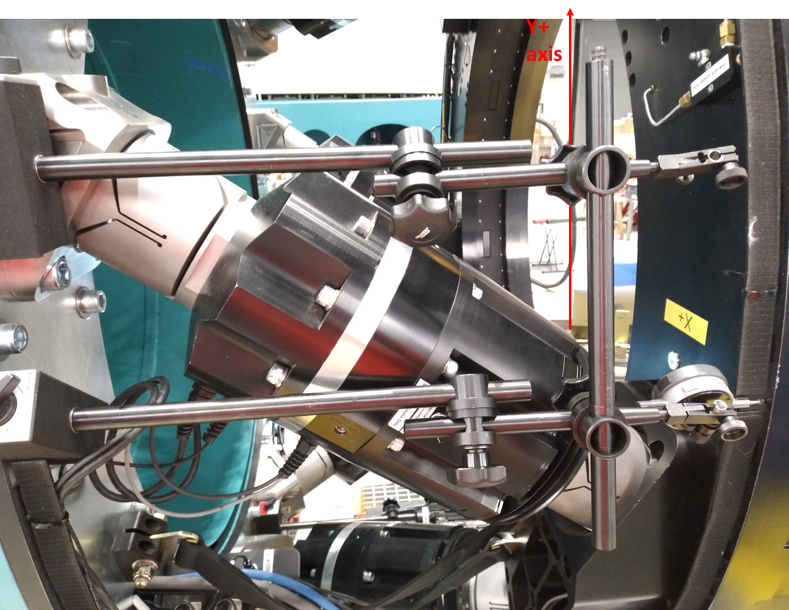

(c)

**Fig.2.** (a) X and Y translational (and rotation about Z, Rz) resolution measuring setup using Mitutoyo Linear Gauges with 1micron resolution. (b), Z translation resolution (Zy-) and rotation X (Rx) measuring setup. (c), Z translation resolution (Zx+) and rotation Y (Ry) measuring setup.

From lessons learned in previous testing, the setup of the linear gauges now included newly bought, more robust, gauge supports and extensions.

The Laser Tracker Leica AT960/930, was used to verify the absolute accuracy, positioning ranges and

hexapod space envelope. The setup is shown in Fig.1. Mitutoyo-absolute-digimatic-indicator linear gauges, models 543-472B and 543-792, 1um resolution, were used to perform the resolution and repeatability verification, the setups are shown in Fig.2.

**3. Measurements**

**3.1. Translation Resolution in Z** (Focus) (LTS-206, **3.3.7**)

Equal or better than 1um. Critical because IQ is most sensitive to this optical term due to the design.

Using linear gauges to measure the Z displacement, with the hexapod in Offset Mode, the EUI was commanded to perform three sets of offset sequences. The first with an offset of 5um, the second with an offset of 2um and the third with an offset of 1um. The Table1 below, shows the results obtained on an exceptionally quiet day in the 3rd floor of Rubin Obs the 14th June 2021.



**Table 1.** Shows that the LSST camera hexapod meets the Z displacement resolution specs. The commanded offset of 5, 2 and 1um, are executed to within an error < 50% of the commanded value, [1] and [4].

**3.2. Rotational Resolution Rx and Ry** (Tip-Tilt) (LTS-206, **3.3.9**)

Equal or better than 8.19x10-5Deg= 0.29484ArcSec. Critical for IQ improvement by minimizing OPD.

With the hexapod in Offset Mode, the linear gauges installed as shown in Fig.2, measure Y and Zy displacements when a rotation offset around the X axis is given, Rx. Similarly, the gauges X and Zx measure displacements in these directions, when a rotation offset around the Y axis is given, Ry. Three sets of offset sequences were measured for Rx and Ry. The first set is five times the resolution, i.e. 5x8.19exp-5Deg, the second set is twice the resolution, 2x8.19exp-5Deg, and the third set is the required resolution specification of 1x8.19exp-5Deg.

The results are shown in Table 2. (a) and (b) below, where a last set of resolution measurements in offset mode were done after sending the hexapod to zero in absolute mode.

(a)



(b)



**Table 2.** Rotation Resolution Rx (a) and Ry (b), show that the Rx and Ry rotations meet the resolution specs. The offset is executed to within an error smaller than 50% of the commanded value [1] and [4]. There is one outlier of 80% with the larger offsets, Table 2 (b), but that is bound to be a gauge stiction problem or similar.

**3.3.** **Translation Resolution in X and Y** (Decentre) (LTS-602, **3.3.5**)

Equal or better than 5um. Critical for IQ improvement by minimizing optical misalignment.

With the Hexapod in Offset Mode and the linear gauges in the setup shown in Fig.2, gauge X measures x axis displacement offsets and Y gauge measures y axis displacement offsets. As in the previous sections 3 and 4, three sets of offset sequences were measured for X and Y. The first set is 5 times the required resolution the second set is twice the resolution and the third is the required resolution specification. Results are shown in Table 3 below. Where (a) corresponds to X resolution move measurements with the centre of rotation (COR) defined near the rotator surface and (b) Y moves with COR at the vertex of the first surface of the first lens of the camera (L1S1).

(a)



(b)



**Table 3.** Translation Resolution X (a) and Y (b). Show that the X and Y translation meet the resolution specs. The offset is executed in average to within an error smaller than 50% of the commanded value as well as resolving most of the time down to a 2um offset, with COR at the rotator plane or at the L1S1 vertex plane, [1] and [4].

**3.4.** **Rotational Resolution Rz** (hexapod twist) (LTS-602, **3.3.11**)

Equal or better than 60x10-5Deg= 2.16ArcSec. Hexapod twist could only be used for engineering purposes and is not part of the IQ budget nor will be used in operation. Still, meeting that spec, is yet another hexapod functionality sanity-check.

Results are shown in Table 4. Where (a) is COR near rotator and (b) COR at L1S1, the camera Lens1.

(a)



(b)



**Table 4.** Rotation Resolution Rz. It shows that the RZ rotations in average meets the resolution specs. The offset is executed to within an error <50% of the commanded value at two different CORs, from [1] and [4].

**3.5. Hexapod Repeatability** (Operational requirement) (LTS-602, **3.3.12**)

Equal or better than 4 times the Resolution spec for the respective movement. So the Camera Hexapod repeatability specification list is the following:

(a) Z translation repeatability = 4x1um = 4um

(b) X and Y translation repeatability = 4x5um = 20um

(c) Rx and Ry rotation repeatability = 4x8.19exp-5Deg= 32.19exp-5Deg = 0.0003276Deg

(d) Rz rotation repeatability = 4x60exp-5Deg = 0.0024Deg

Where the repetition steps are of 50um for translation and 0.0015Deg for rotation [1]

Results of the Camera hexapod translation Repeatability re-verification measurements for axis X, Y and Z are given in Table 5 below.



**Table 5**. Shows that translation repeatability tests meet specification, [1] and [4]. Starting from hexapod position (0,0,0,0,0,0), repeatability testing moves of 50um in absolute mode, are executed to within the specs of <4um for Z moves and <20um for X and Y moves. Note that starting from any other hexapod position away from the zero, means a different setup for the Linear Gauges, so it is not practical to do, because of time.

Results of the Camera hexapod rotation Repeatability re-verification measurements Rx, Ry and Rz, are given in Table 6 below.



**Table 6**. Shows that the camera hexapod rotation repeatability meets specs. The commanded rotation repetition step is reached to within the 32.76exp-5Deg spec for Rx and Ry and the 240exp-5Deg spec for Rz, [1], [2] and [4].

**3.6.** **Hexapod Absolute Accuracy** (hexapod operation spec) (LTS-206, **3.3.13**)

Equal or better than 25 times the Resolution spec for the respective movement. Therefore the camera Absolute Accuracy specification list is the following:

(a) Z translation absolute accuracy = 25x1um = 25um

(b) X and Y translation absolute accuracy = 25x5um = 125um

(c) Rx and Ry rotation absolute accuracy = 25x8.19exp-5Deg = 0.0020475Deg

(d) Rz rotation absolute accuracy = 25x60exp-5Deg = 0.015Deg

The Camera Hexapod EUI set to absolute mode, commanded moves to 25%, 50%, 75% 100% of the maximum range, in the positive and negative directions. The position arrived at was measured with the laser tracker. Results of the hexapod translation and rotation absolute accuracy re-verification measurements are given in Table 7 (a) and (b), below.

(a)



(b)



**Table 7**. (a) shows that the camera hexapod translation Absolute Accuracy meets specs. All commanded moves in X, Y or Z, are reached within the required specs of <25um for Z and <125um for X and Y. (b) shows that the Camera Hexapod Absolute Rotation Accuracy meets the specs. Commanded moves are reached within the required specs of 0.0021Deg for Rx, Ry, [4]. Unfortunately, a set of measurements of Rz, as defined in [2], is missing. Left behind because it isn’t a movement expected to be used in operation, so was given little priority.

**3.7.** **Hexapod Translation Z range** (hexapod operation spec) (LTS-206, **3.3.6**)

In absolute positioning mode, move to the following positions in the Z-axis corresponding to the maximum axial translation of +/-7.6mm with all other axes at their zero positions and record the positions measured with a laser tracker. These maximum values should be reached within the absolute accuracy requirements of 25um in Z. Results in Table 9 below.



**Table 8**. The camera hexapod Z translational range meets specs. Positions reached within 25um. This test was not done exactly as the Moog procedure says (+/-8.7mm) because of time constraints. Instead, we just extracted the data from the absolute accuracy test

**3.8.** **Hexapod XY translational range** (hexapod operation spec) (LTS-206, **3.3.4**)

In absolute positioning mode, move to positions in the XY plane corresponding to the maximum translation of +/-7.6mm with all other axes at their zero positions and record the positions measured with a laser tracker. These maximum values should be reached within the absolute accuracy requirements of 125um in XY.



**Table 9**. The camera hexapod translation range meets specs. All commanded value reach range within 125um.

**3.9.** **Hexapod Rotational Rx Ry range** (hexapod operation spec) (LTS-206, **3.3.8**)

In absolute positioning mode, command moves in the RXRY plane to the maximum tip/tilt rotations of +/-0.24°, with all other axes at zero position and the COR nominal. Measure with a laser tracker. Positions should be reached within 205x10-5deg (0.0021Deg) in RXRY, [1] and [2].



**Table 10**. The camera hexapod rotational range meets specs. Positions reached within 0.0021Deg.

**3.10. Hexapod Positioning** (LTS-206, **3.3.1**)

With the COR -2758400um, i.e. at 1.938m in front of the rotator to camera interface on the vertex of L1S1, move the camera hexapod to the following locations in absolute positioning mode and verify the position was reached, within the absolute accuracy specifications of 25um in Z, 125um in XY, 205x10-5deg in RXRY, and 1500x10-5deg in RZ.

This test can be performed at any elevation angle, but 0 deg is preferred (worst-case loading).

In this re-verification test, the camera is horizontal i.e. El=0Deg and the positioning was verified with the laser tracker. The results are shown in Table 10 below.



**Table 11**. The camera hexapod positioning mostly meets requirements. Except for some marginal outliers, the XY accuracy is 29um RMS and the RxRy angular accuracy is 0.0015Deg RMS both meeting specs. The Z positioning is 31um RMS, apparently not meeting the spec of 25um, but this is because the laser tracker resolution is roughly 30um (in fact, most likely all laser-tracker based measurements are limited by this resolution value). The Rz requirement of positioning accuracy <0.015Deg has not been checked (tbd).

**3.11. Hexapod centers of rotation** (LTS-206, **3.3.2**)

Using the Laser tracker to measure the displacement in Y, Rx rotations around the X axis were commanded in absolute mode. The measurements were repeated with COR nominal (-2758400um i.e. at the vertex of L1S1) and COR at the surface of the Rotator (i.e. -820400um). The measurements are shown in Table11 below, and the plot of the Y displacement versus Rx angle is shown in Fig.3.



**Table 12**. The measured Y displacement for a commanded rotation Rx, agrees with the expected value to within 35um RMS i.e. smaller than the absolute accuracy of 125um.

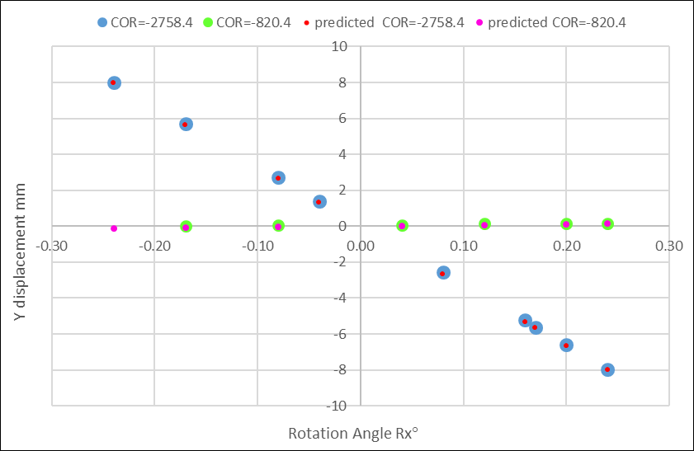

**Fig.3.** The measured and predicted Y displacement for a commanded Rx rotation coincide to better than 35um. The data on COR -820400um (-820.4 on plot) corresponding to pivot on rotator surface, is from March 2021. The data for COR -2758400um (-2758.4 on plot) pivot at L1S1, is from March 2021 and June 2021 after the camera hexapod actuators refurbishing, both sets of data coincide well. So COR definition works as expected.

**3.12. Hexapod cross-talk motion** (LTS-206, **3.3.3**)

This requirement is not tested independently, but is included in the accuracy, repeatability, and resolution testing to the extent that is practical. Cross-talk should be less than the absolute accuracy requirements of 125um in XY and 25um in Z (cross-talk in the rotational axes cannot be simultaneously determined), [1] and [2].

(a)

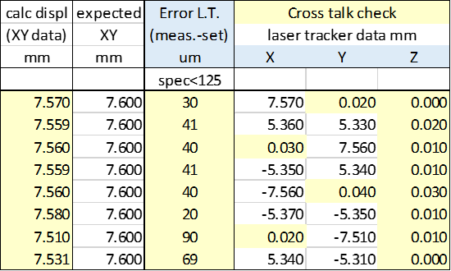

(b)





**Table 13**. (a) Using the data from the X and Y Translational Range measurements (LTS-206, 3.3.4) and (b) from Rx and Ry Rotational range measurements (LTS-206, 3.3.8), the camera hexapod translation range’s cross talk is shown to meet specs. All commanded moves reach destination with the inactive dimensions’ residuals being <125um for X and Y and <25um for Z.

**3.13.** **Hexapod Rotational Rz range** (hexapod good to have for engineering) (LTS-206, **3.3.10**)

Never checked the full range because of time and not critical, so lower priority, tbd anyway.

**4. Conclusions**

Table 14 below, shows a summary of the results of Camera Hexapod hardware re-verification tests.



**Table 14**. Summarizes the hardware performance of the LST Camera Hexapod in terms of meeting the requirement specifications as established in [1], [2], [3].

Basically the fundamental requirements for Image Quality and Image Quality correction as well as operational requirement specifications, all seem to be met satisfactorily without load. It is not expected to change appreciably with the camera mounted on the Hexapod and Rotator, but some more testing, for completion, will probably be done with load.

**5. References**

[1] Hexapod and Rotator Specification Document, D. Neill, J. Sebag, W. Gressler, LTS-206, 2014.

[2] LSST Hexapods and Rotator Acceptance Test Procedure, TP-7403-100, 9/25/17.

[3] LSST Hexapods and Rotator Acceptance Test Report, TR-7403-100, 4/27/18.

<https://confluence.lsstcorp.org/display/LTS/Optical+Work-+Roberto+Tighe>

[4] Cam.Hex&Rot.tests_06072021_rev.6.5.xlsx, R. Tighe, M. Rivera, June-July 2021.

[5] Camera_hexapod test_moves 2021-03-23&24-Results only.v2.xlsx.